**Proactive Attrition Management Logistic Regression Business Case**

Q1. Data cleaning including missing values, outliers and multi-collinierity. Describe your predictive churn model. How did you select variables to be included in the model?

A1.

**Missing values**

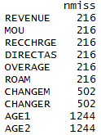

Number of missing values were calculated and were imputed using Knn imputation, same can also be done using MICE package.

**Outliers**

Outliers were imputed with 0.01 percentile value for lower case and with 0.99 percentile value for upper case.

**Variables Selections**

Using Step- AIC from the Mass Package

**Multi-collinierity**

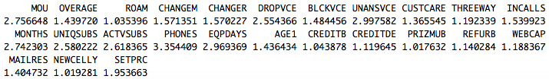

**Selection of Variables**

Selection of variables were done by StepAIC method, then considered significance of variables in creation of logistic model. Then finally checked for multi-collinierity and kept only those variables which were having value less then or equal to 4.

**Final Selected Variables for model**

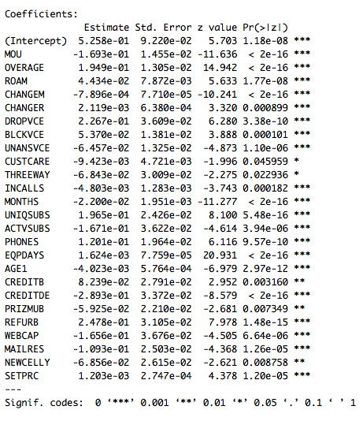

Q2. Demonstrate the predictive performance of the model.

A2.  **Decile Analysis**

For Calibration Data

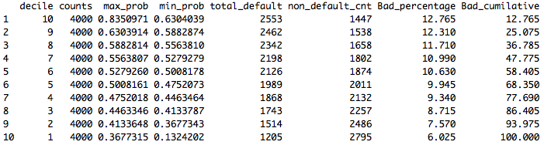

For Validation Data

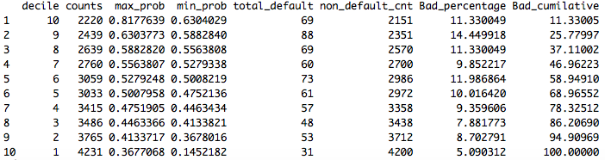

**KS Analysis**

For Calibration Dataset

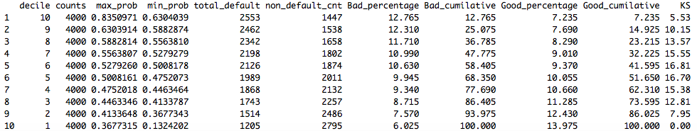

For Validation Dataset

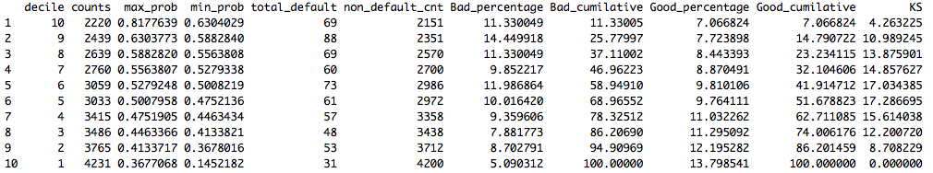

**Confusion Matrix Accuracy Check**

Cutoff taken was 0.44 as it covered 85% of the churned customers. You can take any value depending on the business acumen.

For Calibration dataset

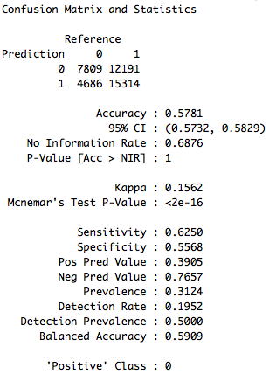

For Validation Data

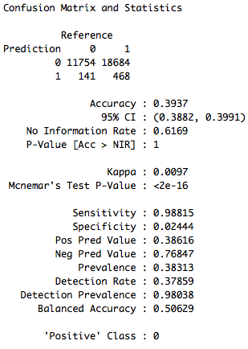

**AUC value**

For Calibration Dataset



For Validation Dataset



Q3. What are the key factors that predict customer churn? Do these factors make sense?

A3. The important factors that predicted the customer churn is EQPDAYS, OVERAGE, MONTHS, CHANGEM, MOU

EQPDAYS – Number of days of current equipment

OVERAGE – Mean overage minutes of use.

MOU – Mean monthly minutes of use.

MONTHS – Months in Service.

CHANGEM - % change in minutes of use.

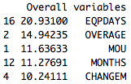

**Factors makes sense like –**

1. EQPDAYS – As the number of days passes the technology becomes obsolete and customer buys the new phone with new technology bundled with better telecom plans to avoid 60% of churning customers.
2. OVERAGE – IF the call minutes are limited and over usage may lead to higher billing.
3. MONTHS – Customers expectation for better services increases as his loyalty to a brand increases .
4. CHANGEM – Frequent changes in plans will lead to instability among customers.
5. MOU – How many minutes of incoming calls and outgoing calls does the subscriber is doing and attending. It will help the company to track the usage of the subscriber and will accordingly try to offer different services and offers to the customer.

Q4 What offers should be made to which customers to encourage them to remain with Cell2Cell?

A4 **Using Decision Tree -**

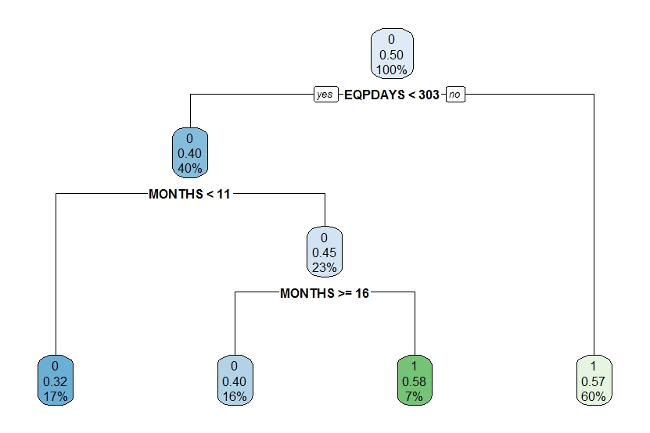

**Offers to be made -**

1. EQPDAYS – Company should do partnership with mobile companies to offer wide variety of options bundled with their telecom plans at good rates and companies can also offer cashbacks on new purchase of to those customers who have already completed 300 days with their old phone using their network (As per the decision tree).
2. OVERAGE – Companies should offer a flexible talk plans according to the age to avoid over billings of customers.
3. MONTHS – Loyal Customers (i.e. Customers completed 12 months on network ) should be offered good telecom packages and cashbacks.
4. MOU – IF the customer is usage is less then company can offer cheaper packs with usage of some free data to increase their consumption. If the customers usage is more then company can upsell or cross sell more heavy packs having large volumes of data and other incoming and outgoing calls services at the optimal rates.

Q5. Assuming these actions were implemented, how would you determine whether they had

worked?

A5 We can see for the yearly churn percentage trend for the customers for both before and after the implementation of actions.

1. For this we have to bucket all the customers in terms of years on the basis of months in service.

Example –

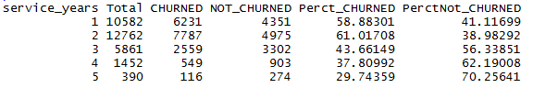

**OR**

1. We can also find the overall % of churned and not churned Customers.

Example –

Capture2.PNG